2023-2024 Satisfactory Academic Progress (SAP) APPEAL

STUDENT INFORMATION

Last Name First Name Middle Initial Student ID#

Phone # Email SSN# Date of Birth

Address City State Zip Code

SAP Appeal Information: The Mississippi College Financial Aid SAP Appeal Process: https://www.mc.edu/offices/financial-aid/satisfactory-academic-progre#:~:text=An%20appeal%20form%20is%20included,and%20Financial%20Aid%20Appeals%20Committee.
Reason for SAP Appeal (Check all that apply):
Academic Suspension
Financial Aid (GPA, Completion Rate, Both GPA and Completion Rate, and/or Max Hours
Attempted)
Undergraduate Readmissions

PART 1: Student’s Letter of Appeal:
You must submit a letter with this form explaining the reason for your appeal. You should provide a detailed explanation of: (a) What caused your academic work to fall below the minimum standards for academic progress while attending MC, (b) What changes have taken place in your life resolving these conflicts, (c) How do you intend to maintain good academic standards and progress towards your degree completion, and (d) Please share any other pertinent information you wish for the Appeal Committee to consider in the review of your SAP Appeal Application. Please attach supporting documentation to substantiate your circumstances (medical documents, obituary, police report, etc.).

PART 2: Academic Plan for Success:
An Academic Plan for Success must be submitted with this appeal application. It is recommended that you develop the academic plan with the Office of Student Success. You must meet the conditions of the academic plan or meet the SAP requirements in order to maintain financial aid eligibility.

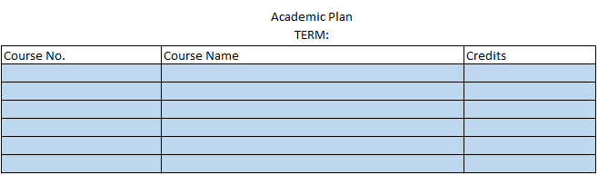

Please keep in mind that the SAP Committee will work expeditiously to review your SAP Appeal, however, the appeal decision may not be available until after classes have begun for the semester in which you are suspended. You are responsible for the payment of all MC charges to your account regardless of the outcome of the appeal.

SIGNATURE

My signature below confirms that I fully understand the financial rights, responsibilities and consequences of my Mississippi College student account. I certify that (a) I have reviewed the SAP policy and acknowledge that my current financial aid status is suspension and I understand that if my appeal is denied, I will not be granted financial aid for this semester and future semesters until I have obtained SAP standards, (b) the courses listed in my academic plan have been confirmed with my academic advisor as acceptable toward completion of my degree program, and (c) my SAP status will be recalculated at the end of the semester. I further understand that until this form is complete and approved, no aid will disburse to my account.

Signature Date

Please submit to the Office of Financial Aid: Mail to Box 4035, Mississippi College, Clinton, MS 39058, email to financialaid@mc.edu or you may bring to the financial aid office located in Nelson Hall.

