1. Go to my.mc.edu.
You can also go to www.mc.edu and click on “MyMC” in the top right corner.

2. Log in using your username and password.
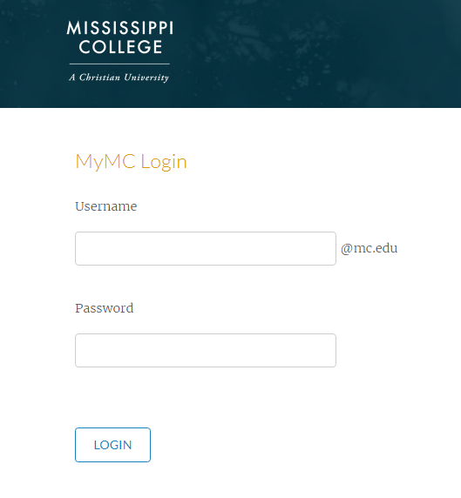
3. Click the “Banner” Icon on the MC Launch Pad.
4. Click on the “Financial Aid” Tab at the top of the page.
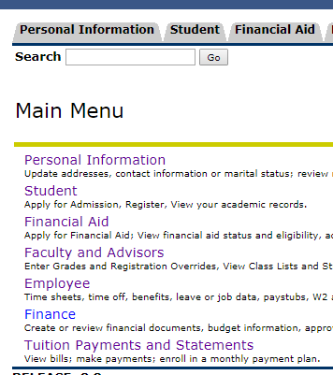
5. Click “Award”
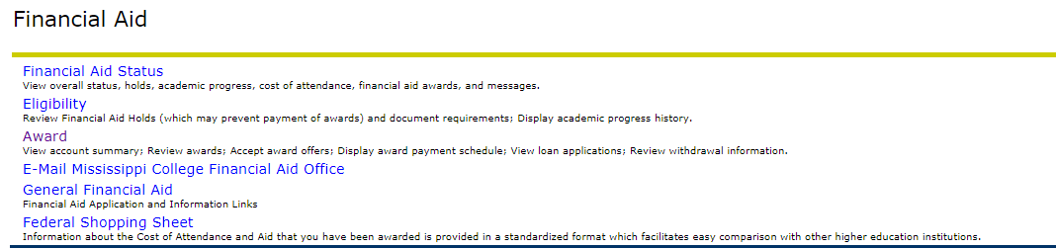

6. Click “Award for Aid Year”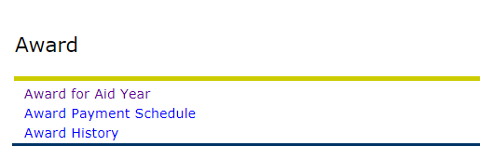

7. Select the Aid Year you are enrolling for using the drop down menu.
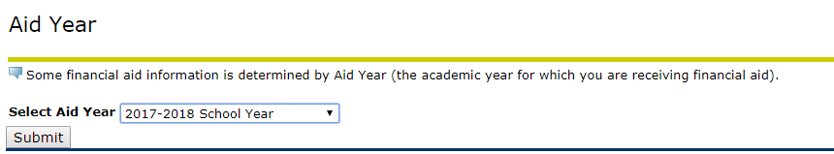

8. Click the “Terms and Conditions Tab.” Read and Accept the Terms and Conditions.

9. Click the “Accept Award Offer” Tab.

10. This will show a breakdown of your award. (Please note your award may look differently than the example shown below. Your award is based on your degree level and federal limits) You can accept the full amount or specify an amount. (*If specifying-use full amount needed for the entire year. It will be split for Fall and Spring). Be sure to click “Submit Decision” to finalize the acceptance or deline of your financial aid.
